Participants of the Taxation and Digitalization in Asia
September 14, 2021

Opening Remarks
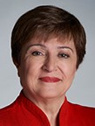
Kristalina Georgieva

Ms. Georgieva is the Managing Director of the IMF since October 1, 2019.
She was CEO of the World Bank from January 2017 to September 2019, during which time she also served as Interim President for three months.
Previously, Ms. Georgieva served as European Commission Vice President for Budget and Human Resources and as Commissioner for International Cooperation, Humanitarian Aid and Crisis Response.
From 1993 to 2010, she held a number of senior positions at the World Bank, including as Vice President and Corporate Secretary in 2008, and as Director for Sustainable Development, Director for the Russian Federation (based in Moscow), Director for Environment, and Director for Environment and Social Development for the East Asia and Pacific Region.
Born in Sofia, Bulgaria, she holds a Ph.D. in Economic Science and a M.A. in Political Economy and Sociology from the University of National and World Economy, Sofia, where she was an Associate Professor between 1977 and 1993. She also was visiting fellow at the London School of Economics and at the Massachusetts Institute of Technology.

Moderator
Emma Agyemang

Ms. Agyemang is the FT’s global tax correspondent covering national and international tax issues affecting companies and individuals. She was previously a reporter for FT Money. She joined the FT group in 2016 as a personal finance reporter on Investors Chronicle. She was named Best Personal Finance Journalist by ADVFN in 2020, a year after winning Business Journalist of the Year at the Words by Women awards. She was also named Best Venture Capital Trust Journalist by the Association of Investment Companies in 2018.

Panelists
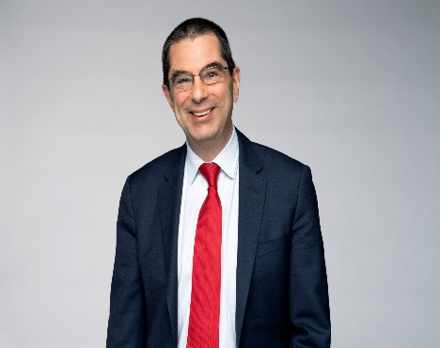
Vitor Gaspar
Mr. Gaspar is Director of the Fiscal Affairs Department at the IMF. He joined in 2014. Before that, he was Portuguese Minister of State and Finance from 2011–13, and has held various positions in European and Portuguese institutions, including head of BEPA at the European Commission, director-general of research at the European Central Bank, director of Economic Studies and Statistics at the Central Bank of Portugal, and Director of Economic Studies at the Portuguese Ministry of Finance.

Mr. Gaspar holds a Ph.D. and a post-doctoral agregado in Economics from Universidade Nova de Lisboa; he graduated from Universidade Católica Portuguesa.

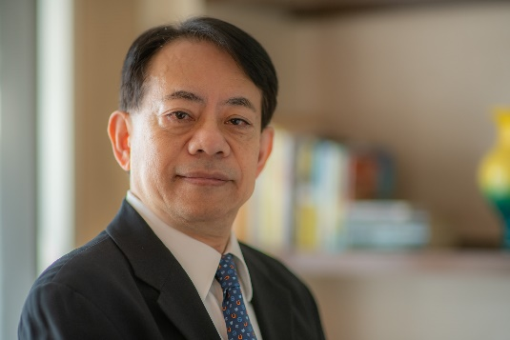
Masatsugu Asakawa
Masatsugu Asakawa is the President of the Asian Development Bank (ADB) and the Chairperson of ADB’s Board of Directors, assuming office on 17 January 2020. Prior to joining ADB, he served as Special Advisor to Japan’s Prime Minister and Minister of Finance, and has a close-to-four decades’ career at the Ministry of Finance with diverse professional experience that cuts across both domestic and international fronts.
Mr. Asakawa obtained his BA from University of Tokyo (Economics Faculty) in 1981, and MPA from Princeton University, USA, in 1985.

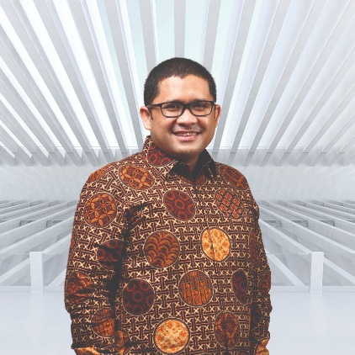
Febrio Kacaribu

Dr. Kacaribu has been the Head of LPEM Macroeconomic and Financial Research since 2015 and was appointed as Head of the Fiscal Policy Agency on April 3, 2020. His areas of expertise include Business Economics & Projection, Economic Models, Financial Economics, Monetary Economics, and Public Policy Analysis.

He obtained a Bachelor of Economics degree in 2002 from the University of Indonesia, and continued his study with a Master degree of International & Development Economics from the Australian National University in 2005. In 2014, he obtained a Ph.D from the University of Kansas.

Huey Min Chia-Tern
Huey Min Chia-Tern is the Deputy Commissioner of International, Investigation and Indirect Taxes Group of the Singapore Inland Revenue Authority. She is also Singapore’s representative to the OECD/ Inclusive Framework on BEPs and its Steering Group, as well as the Global Forum for Transparency and Information Exchange. Huey Min is the Chair of Peer Review Group of the Global Forum.
Ms. Chia-Tern obtained a BSc from National University of Singapore, a Masters in Land Economy from the University of Aberdeen, and a MDP from Harvard Business School. She is also a Representative Council Member of the CPA Australia, as well as a Council Member of its Singapore office.

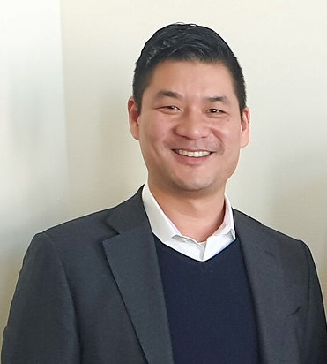
Alan Lee
Alan Lee is the Head of Tax Policy for Facebook. In this role Mr. Lee leads tax policy decisions for Facebook’s work with policy makers and multilateral bodies. Prior to his work at Facebook, Mr. Lee served as Tax Counsel on the Ways and Means Committee – the tax writing committee for the U.S. House of Representatives. Mr. Lee is an attorney and was in private practice prior to his work in tax policy.

