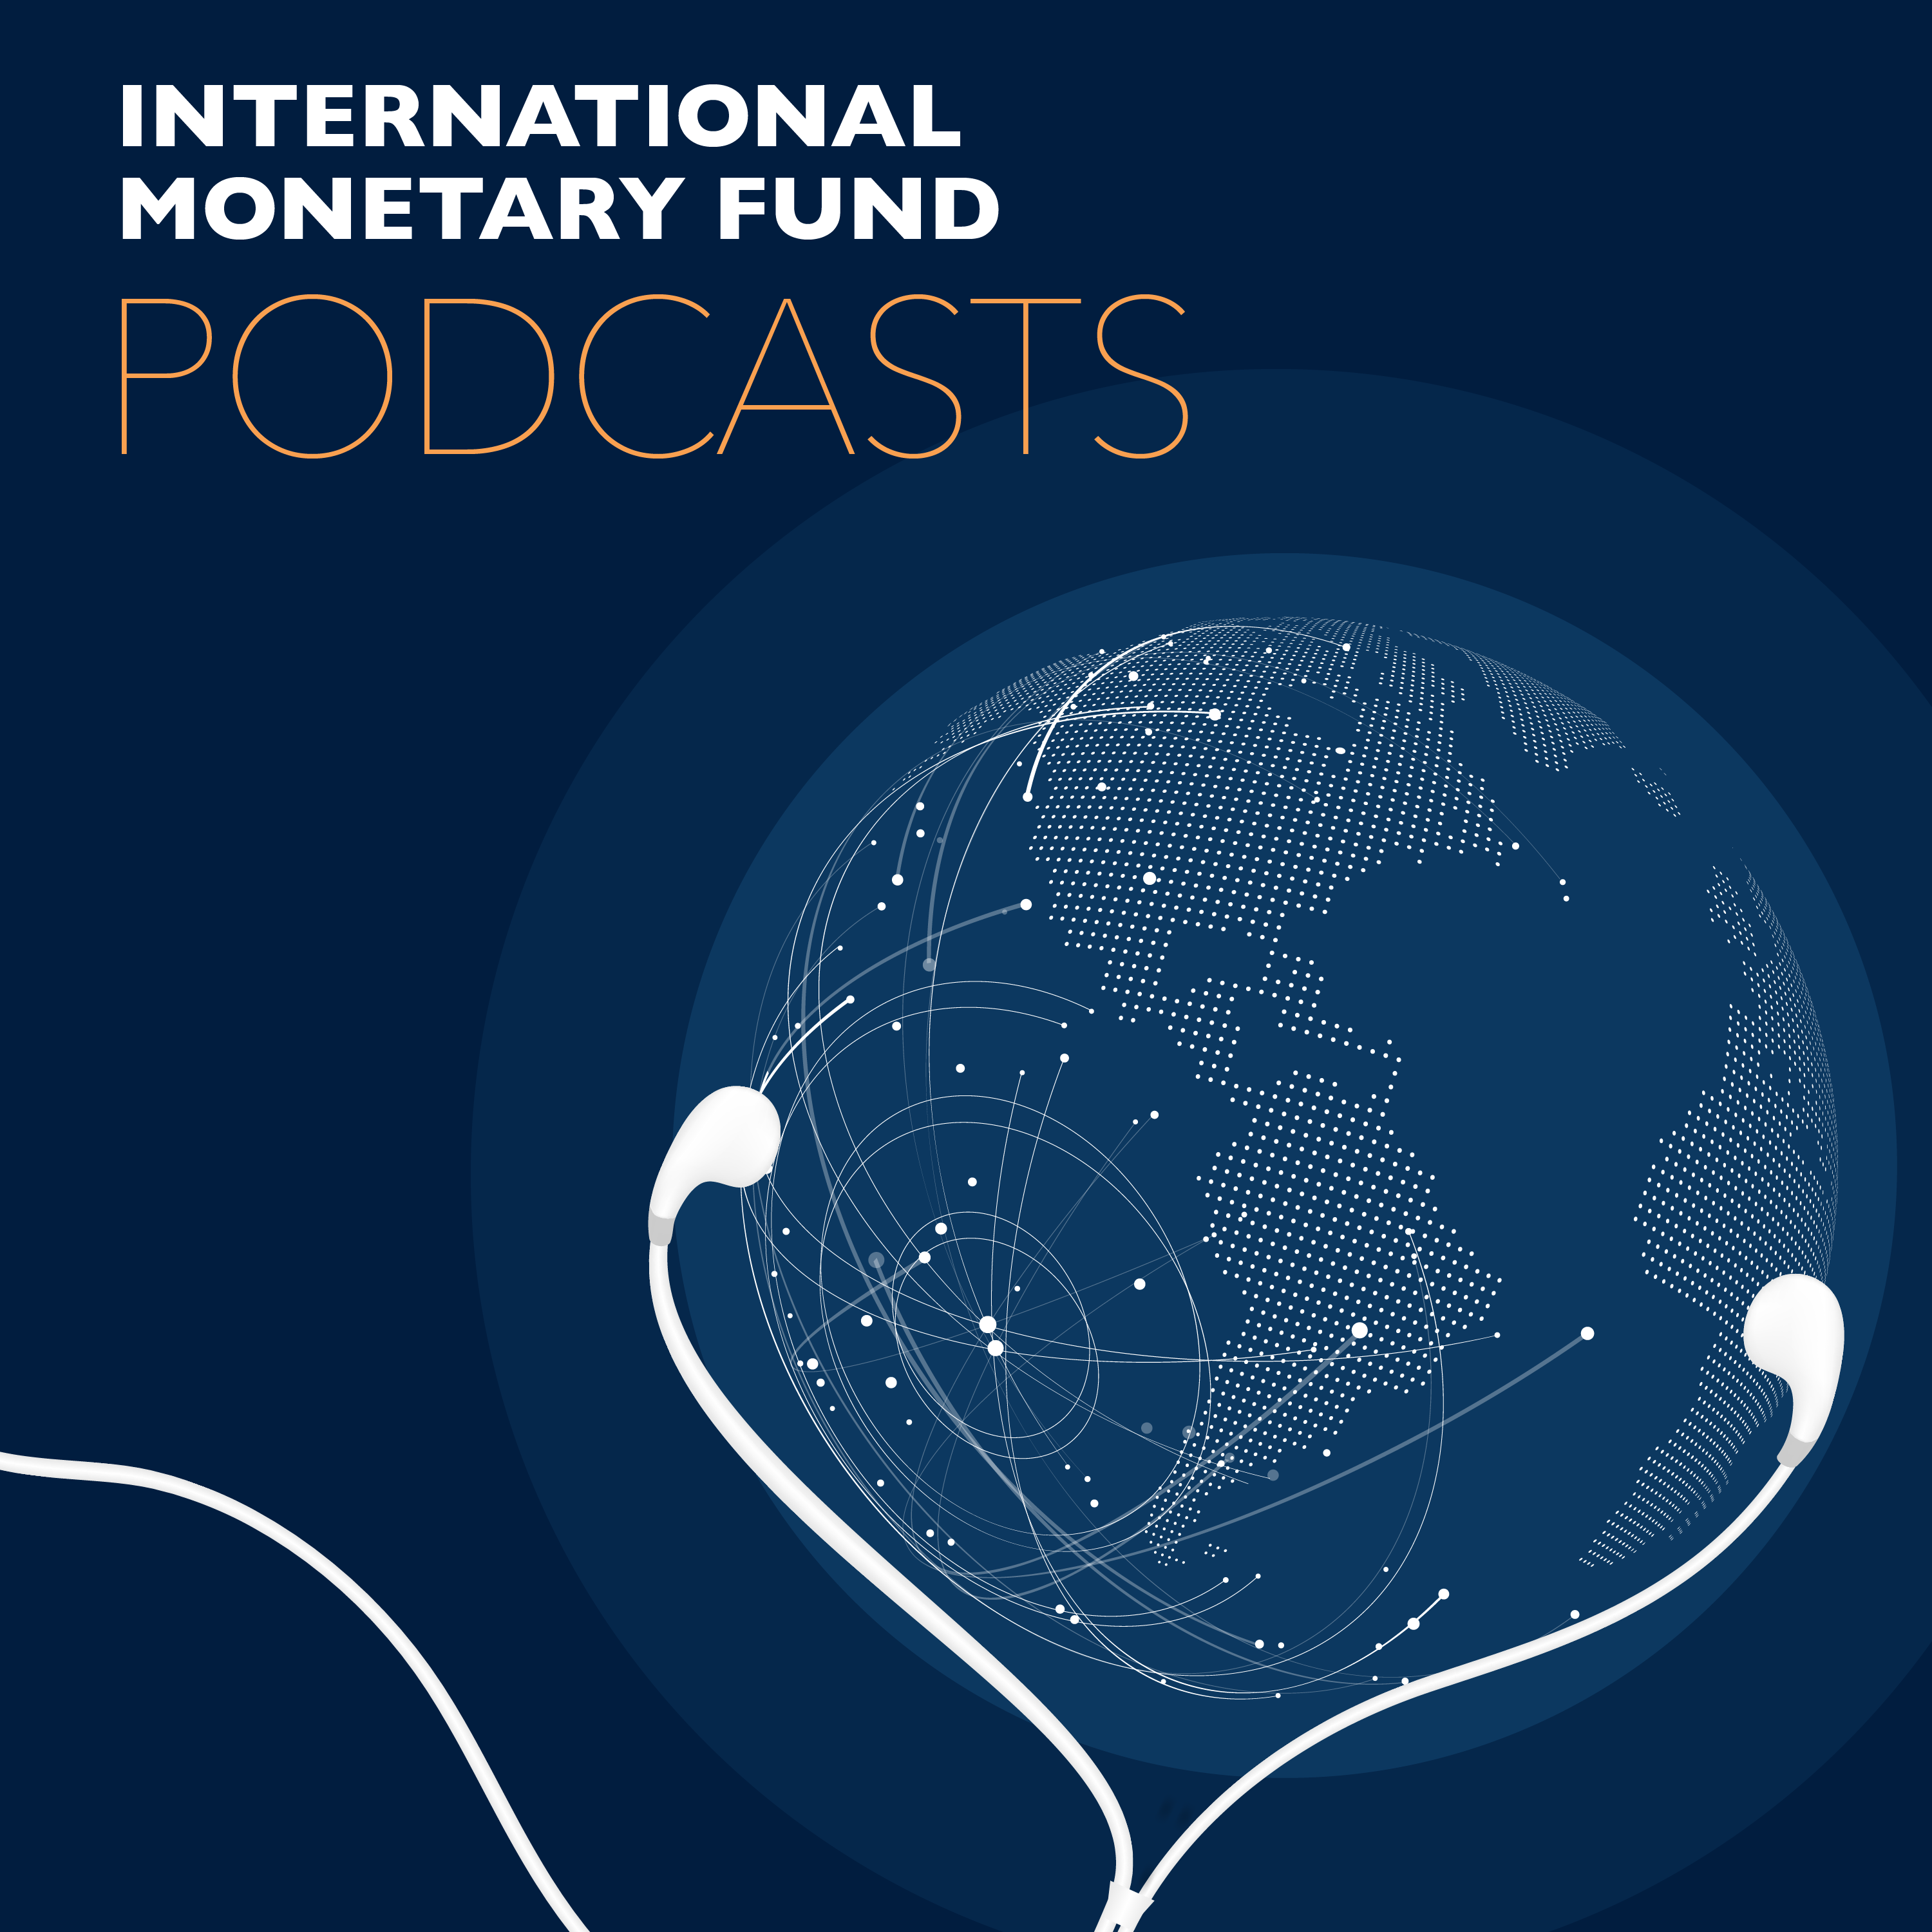
Transcript of IMF podcast:
Kristalina Georgieva and Lord Nicholas Stern Talk Climate
Kristalina Georgieva:
I do believe that the tide is turning on climate. It is turning, unfortunately not because we fixed the economics of climate change. It is turning because mother nature is slapping us now on a regular basis. And it is turning, because our children are saying, "Enough. Enough of that."
Nick Stern:
The young people, our students, who are going out to work ask that their assets have a decent risk return profile, but they also ask that they be responsible, because that's their future that these investments are influencing. And we're starting to find, and the evidence is building, that investing responsibly, from the point of view of environment is actually to invest wisely. Because you're betting on the technologies of the future, not on the technologies of the past.
Bruce Edwards:
Welcome to this podcast, produced by the International Monetary Fund, I'm Bruce Edwards. Mitigating the effects of climate change will take a multifaceted approach with economic policy playing an important role. In this episode, we hear from two influential people in that world, IMF Managing Director Kristalina Georgieva speaks with Lord Nicholas Stern of the London School of Economics about the significance of the special report on climate change published in 2018 by the Intergovernmental Panel on Climate Change, or the IPCC. Nicholas Stern is chairman of the Grantham Research Institute on Climate Change, and author of the Stern Review on the Economics of Climate Change published in 2006. Kristalina Georgieva and Lord Stern met before a live audience at the IMF.
Kristalina Georgieva:
Good afternoon, and thank you all very much for joining me for a conversation with Sir Nick Stern. Nick and I worked together at the World Bank when he was Chief Economist and Senior Vice President. He led the work of the new climate economy. I was one of the commissioners. He has been tirelessly advocating for embracing climate action, not only because the climate crisis is one we have to be all concerned about, but because it is an opportunity for economic transformation, for growth, and for the ability of us to serve countries better. And to start, I'm going to first ask why, when you talk about climate action, the word you start from is urgency? Why is it that you put the emphasis on urgency?
Nick Stern:
It is intensely urgent. A lot of the consequences come later. But urgency of action is now, and I think it's important to start with the science. Not at length, but it's basically at one level simple, and compelling. And that is that greenhouse gases oscillated a frequency that interferes with infrared radiation bouncing back off the earth's surface. That's how it works. And so the stronger the concentration, the more that greenhouse blanketing effect, and the higher the temperature. And CO2 is a very long lived greenhouse gas. So what you essentially have to do to stabilize temperatures, is to stabilize concentrations.
Nick Stern:
And to stabilize concentrations, just like your bath tub, the flows have to be net zero. What's going out the plug hole has to be the same as what's going in as the force it as you call it here. So net zero is stabilizing concentrations, and you need that to stabilize temperatures. The earlier you go net zero, the lower the temperature at which you stabilize. So basically, if we want to stabilize at 1.5 degrees, as we should, and I'll try to indicate why, you got to go net zero for CO2 as a world by around 2050. Two degrees net zero as a world the CO2 to around 2070. Now, I'm simplifying, but that's basically the storyline. And you can see it drop straight out of the physics. Nothing mysterious here. This isn't fancy modeling, and maybe some modeler has got it wrong. This is just the basic physics.
Nick Stern:
Now the urgency then is the difference between 1.5 to 2.5 to 3, now we're currently headed well over three if the world did deliver on what was promised in 2015 in Paris for 2030. We haven't been at three degrees centigrade. This is all average global surface temperature relative to the end of the 19th century. We haven't been at three degrees centigrade for about 3 million years, and then sea levels were 10 to 20 meters higher than now. You had trees in Antarctica. And this is way, way outside human experience. Now we're 250 million years, homo sapiens, but basically, it's the Holocene period, the last nine or 10,000 years, we've been plus or minus one. And we're on the edge of that now.
Nick Stern:
So the danger, I hope, and the urgency then is clear, because we're already at one, it's going to be really tough to hold at 1.5. But just compare 1.5 and two and this is the IPCC report of about 16, 17 months ago. They compared 1.5 and two, and the difference in 1.5 and two is, for example, the average length of a drought doubles. The fraction of people exposed to extreme heat more than doubles. The fraction of people exposed to extreme weather events more than doubles. You lose all the coral. At 1.5 you lose much of it or most of it. At two you lose it all, with profound effects on the way the whole ocean system functions. That's 1.5 and two. You don't really want to imagine three or 3.5, but that is where we're headed in rather a short period of time from the point of view of the history of climate.
Nick Stern:
So if we're going to stabilize at 1.5, then you have to go net zero by 2050. You have to work back from there. The world economy will double in the next two decades. That's at a growth rate of just over 3%, which is probably roughly what it will be. So the world economy doubles in two decades, and in that period just for two degrees, you have to cut emissions absolutely by 40%. If that new economy was completely carbon free, that's nowhere near enough, nowhere near. Because you've got to cut absolutely, you've got to cut emissions per unit of output by 80% in 20 years, just for two degrees. So, that shows how fast we have to change. We have to change in this next two decades, faster, really, our economies than we've changed at any time in the past. And it has to be right across the whole economy because net zero is net zero. There'll be a few negatives, but they probably won't be that big. So there's a... That means all countries, it means all sectors.
Nick Stern:
So that's the magnitude of what we have to do. So it's the urgency because if we lock in our infrastructure in this next decade or two, anything like the infrastructure we've had in the past, infrastructure doubles in 15 or 20 years. So if we put that infrastructure down, looking just like the infrastructure in the past, our emissions will leap up, not leap down. Those infrastructure decisions, investment decisions, the investments actually being made in the next 15 years, those decisions are now. So this is intensely urgent, and it's the whole economy. All sectors, all countries.
Kristalina Georgieva:
My wake-up moment came when the IPCC report, with a very sober assessment of climate change happening faster than our predictions came out. So I read this report, and I... That night I could not sleep. That night, I was thinking, what have we done? And I was thinking of my granddaughter that's eight years old. What we have learned is, by the time she's 20 years old, there would be 100 million more extremely poor people, because of climate change. By the time she's 40 years old, there would be 130 million climate refugees at least. And if she were to be lucky enough to live to be 90, by the time she's 90, the planet would be barely livable unless we act now. And I think it is very important for us to all recognize that this is action by everyone, by every individual, by every organization, by every country.
Kristalina Georgieva:
I want to tell you something, Nick, that at the Fund is something that is very high on the minds of people. And I am so very convinced that climate change is macro critical. It is straight in our alley, straight into our mandate. And for us, it means to take what we do in fiscal, in financial, in monetary, and then say, "How we integrate climate action in all of this core areas of our work?" What does it mean for pricing carbon? How we can advance taxing carbon in our member states, what we do to create buffers against shocks through the fiscal system in countries, and how we improve the quality of expenditures, what you talked about, the investment decisions that are being made today, so we are actually going to ensure a better future for our children. And then we have a very strong commitment to work with the network of central banks looking at greening financing. For us to be very active in reporting on climate related financial risks in a standardized manner.
Kristalina Georgieva:
And then being able to do what the Fund is so good at, to stress this, the financial system for this new category of risks. And we have to be able to think of climate action not as a drag on the economies, but as a booster. Transformation to low carbon, to climate resilience, is actually good investment in more sustainable growth, better jobs for people. Now, this is what I love about Nick. There are many people in the climate community that usually stop their talk at, it is really bad, the sky is really falling. But Nick actually turns this on the positive side, and actually convinced that climate action may be the silver bullet that we need at the time of low productivity growth, low economic growth, low interest rates, low inflation. So sell that positive story, Nick.
Nick Stern:
Thank you. Kristalina, what you've already said when you described your reaction to reading that report underlined very firmly that this is a story about growth and stability. An unsustainable world, an unsustainable set of policies, unsustainable economic activity is tomorrow's instability. So this is a growth and stability story. That's, as you rightly point out, if you're negligent, then you undermine growth if you cause instability. But there's a much more positive story, and it's this. And you already introduced it very powerfully, Kristalina, this is the story that says we live in a world that's demand constrained. Interest rates are on the floor. They're wonderful investment projects out there, but public... And the more we discover about what we can do, the more there are, but we need policy that pulls through possible investments into real propositions and programs. And then you need the right kind of finance available, on the right scale at the right time. But this is-
Kristalina Georgieva:
How about the losers? How about those guys that are going to be hit, because they are in a place that is depending on coal, or they are in a country that is oil dependent. How about them? What would you... What is the dream of a sustainable growth you will sell them?
Nick Stern:
Absolutely. But the first is to see... And I come exactly to that in just a moment. That the first thing is to see those opportunities, because it's not only boosting demand and sharpening supply in the shorter run, but it is also a Schumpeterian story of discovery, innovation, investment and growth. But you're absolutely right, and Schumpeter was very clear, that's creative destruction. So as you move, as you innovate, as you go beyond the old technologies, which are out of date for the reasons we've described, there's dislocation. There's inevitably dislocation. And it's one thing to say that actually, and you can say, that there's so many more jobs in these new exciting industries, whether it's installing solar on roofs, or decentralized solar in Indian village, or wherever it might be. There's so many opportunities there, but they are not necessarily things into which coal miners instantly go.
Nick Stern:
Mercedes and BMW, they've been slightly slow in the game, but they're moving now, can move into electric cars. But in their supply chain, the people who make the pistons, they don't necessarily get in on the act of the new cars. So you've got an economy which is growing. That's got net far... Creating net far more opportunities than it destroys, but you can't simply say to people, "Well, that's tough on average, it's all better off. But it's a pity you're the ones who suffered, but that's life." And that is I think a responsibility of social cohesion, a responsibility between ourselves as citizens, with duties that we owe each other, and that it's basically a moral imperative to find ways of policies that can help those people participate. But it is also key to sustainability as well, because if you create powerful, understandable, interests against these policies, you may not be able to take them through. So it's not only the moral thing, it's actually practical.
Kristalina Georgieva:
Yep. I want to finish on the somewhat upbeat point, because I do believe that the tide is turning on climate. It is turning, unfortunately, not because we fixed the economics of climate change. It is turning because mother nature is slapping us now on a regular basis. And we are waking up for that reality more than we did five years ago, 10 years ago. And it is turning because our children are saying, "Enough. Enough of that." Now we can lean in the direction of the populists and the denials and that they say, "Oh no, that's not really true. Don't worry, it's not going to be bad." Or we can line up on the side of our children. Our choice.
Kristalina Georgieva:
Institutionally, I strongly believe that our shareholders overall see this as a macro-critical issue, because they do see the shocks shaking up economies. Remember, Dominica, comes Maria, 225% of GDP wiped out. What we need to do is to act on that agenda, strictly within the parameters of our mandate. And our mandate is financial stability, growth, employment, sustainable overtime. This is our mandate. And I do believe that we have the people at the Fund that take this to heart. I do believe that we are at the point of time where we actually can serve our members, rich and poor, emitters and vulnerable to climate shocks countries, more by taking to heart our duty to serve. And I do hope that we can have an institution that can, 10 years down the road, look back proudly at what we have done in this critical moment when the name of the game is we are running out of time. Let's give Nick a big, big round of applause. Thank you, Nick.
Nick Stern:
Kristalina, thank you for having me. But above all, thank you for your leadership. This is extremely important, and the world is in your debt. Thank you.
Kristalina Georgieva:
Thank you.
Bruce Edwards:
That was IMF Managing Director Kristalina Georgieva, and Lord Nicholas Stern of the London School of Economics speaking before a live audience at the IMF. Nicholas Stern is chairman of the Grantham Research Institute on Climate Change. There's lots more to learn about the macro economic impacts of climate change at imf.org. And if you like this podcast, look for us on Spotify or on your favorite podcast app, just search for IMF Podcasts. And follow us on Twitter @IMF_podcast. Thanks for listening.

