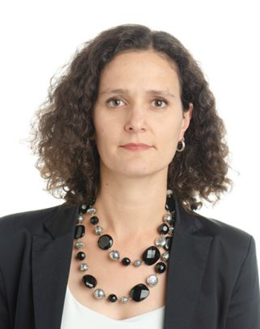 | Dora Benedek is a Deputy Division Chief at the Tax policy division of the Fiscal Affairs Department of the IMF. She joined the Fund in 2011 where she has been engaged in Technical assistance and tax policy related analytical work, as well as country work on Bosnia and Herzegovina and Belarus. Prior to her Fund career she worked in the public administration in Hungary, first at the Ministry of Finance, followed by the Office of the Fiscal Council where she was leading the work of the tax policy analysis team. Her analytical work focuses on tax policy, labor market issues, inequality and microsimulation. She has a PhD in public finance from the Central European University.
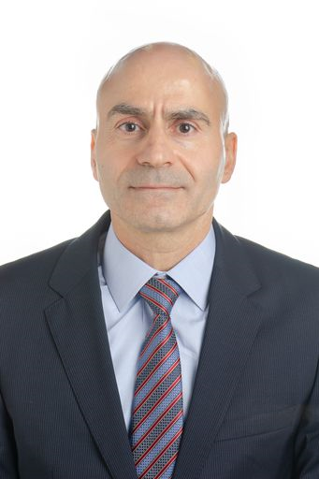 | Edward R. Gemayel joined the IMF in 2001. Currently he is an advisor in the African Department and mission chief for Chad. Previously, he held various managerial positions in the Strategy Policy and Review Department as well as in the Middle East and Central Asia Department. He also led missions in Africa, the Middle East, and Central Asia.  Before joining the IMF, Mr. Gemayel was a Division Chief at the Central Bank of Lebanon and prior to that he worked for two years in investment banking. He was also a lecturer in economics and finance at the American University of Beirut and the Universite Saint Joseph. He is a graduate of McGill University and Concordia University.
Luc Eyraud is currently mission chief for WAEMU countries in the African Department of the International Monetary Fund. Mr. Eyraud leads the annual Article IV consultation with the WAEMU regional authorities. Prior to this, Mr. Eyraud was mission chief for Benin and, earlier, team leader of the Fiscal Monitor in the Fiscal Affairs Department. Since he joined the IMF in 2007, he has worked on a number of program and surveillance countries in all regions of the world, including Argentina, Chile, Cyprus, Georgia, Hungary, India, Italy, Japan, Madagascar, Mauritania, Paraguay, the Philippines, Portugal, Romania, South Africa, Spain, and Togo.
Most of his research focuses on fiscal policy, including fiscal institutions and fiscal multipliers. He has published extensively on fiscal rules and fiscal decentralization. More recently, he has coordinated several projects on the financing of African economies.
Before joining the IMF, Mr. Eyraud worked as a civil servant at the French Treasury. He is a graduate of the Ecole Normale Supérieure and the University Paris Sorbonne. He also holds a degree in econometrics from ENSAE.
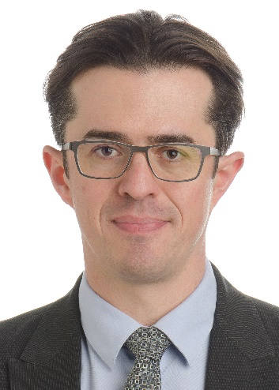 | Adrian Peralta-Alva has been Assistant to FAD director since 2019. Prior to this, he was senior desk for Botswana and Namibia in the African Department. Dr. Peralta-Alva developed the models and lead the inequality group of the IMF-DFID collaboration, from its beginning in 2012 and until 2016. Recently, Mr. Peralta has continued the macro distributional agenda extending it to advanced economies, including the most recent Article IV of the United States, and the Fall 2017 and upcoming April 2018 Fiscal Monitor. Prior to joining the IMF Mr. Peralta was Professor of Economics in the University of Miami, Senior Economist in the Federal Reserve Bank of St. Louis and Adjunct Faculty for Ph D students in the Department of Economics of Washington University in Saint Louis. Mr. Peralta has published extensively in top peer reviewed economics journals. His areas of research include monetary economics, macro financial linkages, and more recently, macro distributional issues. Mr. Peralta-Alva holds a Ph D in Economics from the University of Minnesota.
 | Elise Hadman is Deputy Head of Unit for Sustainable Finance Policy in the Directorate General for International Partnerships of the European Commission. Ms. Hadman has been working for the European Commission since 2009, in external relations. She has worked as economic advisor in the EU Delegation to Côte d’Ivoire, as head of section for Central Africa and team leader for Financing for Sustainable Development. She holds a Master’s in political science from Sciences Po Paris and a Masters’ in European Political and Administrative Studies from the College of Europe.
Thomas Beloe – Chief of Programme, UNDP Finance Sector Hub
With over 20 years of experience in providing policy advice to governments across Africa, Asia, Latin America and the Pacific, Tom works as Chief of Programme for UNDP’s Finance Sector Hub which works across more than 170 countries to align and mobilise finance for the Sustainable Development Goals. Tom also leads UNDP’s work to support governments in aligning all sources of finance behind the SDGs as part of Integrated National Financing Frameworks. Tom’s work at UNDP over the last 13 years has also included a focus on climate change finance. Tom previously worked for think tanks and NGOs as well as the UK government’s Department for International Development for ten years. He has a MA in Anthropology from Cambridge University as well as an MSC Social Policy and Planning from the London School of Economics.

